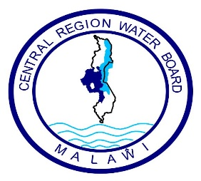

**Central Region Water Board**

**Request for Quotations (RFQ) for BOREHOLE BLOWING FOR 13 BOREHOLES**

1. The Central Region Water Board is inviting eligible bidders to Provision of Services for Borehole Blowing through Request for quotations.
2. Interested eligible Suppliers must be registered with M.R.A, P.P.D.A and M.S.M.E and will be required to complete a set of Request for Quotations which can be downloaded from Central Region Water Board website
3. Sealed Bids must be delivered and deposited at CRWB head office **on or before 14.00 hours on Friday 22nd September 2023 clearly marked with Request for Quotation for Borehole Blowing** as indicated above**.**
4. Bids will be opened at **Central Region Water Board** on **Friday 22nd September 2023** at **14.00 hours’ local time.** Late bids shall be rejected.
5. Central Region Water Board reserves the right to reject any or all bids and is not bound to accept the lowest or any other bidder.
6. Addresses for:
7. Clarifications**:**

**Attention: Mr. Time Nyalapa – Acting Procurement and Disposal Manager**

**Central Region Water Board Offices**

**Area 4, Murry Road**

**Opposite Immigration Offices**

**Private Bag 59**

**Lilongwe**

**Malawi**

**Phone No: 265 (0) 310002128**

**Cellphones: 0999 203 621 / 0888 903 621**

**Email:** [**crwb@crwb.org.mw**](mailto:crwb@crwb.org.mw) **/** [**tnyalapa@crwb.org.mw**](mailto:tnyalapa@crwb.org.mw)

1. **Submissions**

**Attention: Engineer John Makwenda – Chief Executive Officer**

**Central Region Water Board Offices**

**Area 4, Murry Road**

**Opposite Immigration Offices**

**Private Bag 59**

**Lilongwe**

**Malawi**

**Phone No: 01 758 044 / 045/ 046**

**Cellphones: 0881 707 535 / 0996 707 535**

**Email:** [**crwb@crwb.org.mw**](mailto:crwb@crwb.org.mw) **/** [**jmakwenda@crwb.org.mw**](mailto:jmakwenda@crwb.org.mw)